1.Purpose
This experiment aims to examine the effects of initial velocity and launch angle on the maximum height and range of an object. In addition, the experiment wants to show that mass is not influential on range and maximum height. Also, we will learn the fundamentals of Tracker and Ballistic Unit at the end of the experiment. One of the purposes of the experiment is realising the fact that there is always an error in real life experiment compared to theoretical calculations.

2. Theory
A List of Materials
1) Ruler
2) Camera
3) Steel Ball
4) Wood Ball
5 Projectile Launcher
6) Paper

In this experiment, we conducted a projectile motion experiment using Projectile Launcher. We throw the steel ball at different angles such as 30 degrees , 45 degrees and 60 degrees to examine effect of throwing angle to range and maximum height. Moreover, we throw steel ball from different power levels of projectile launcher to examine effects of the force to initial velocity.
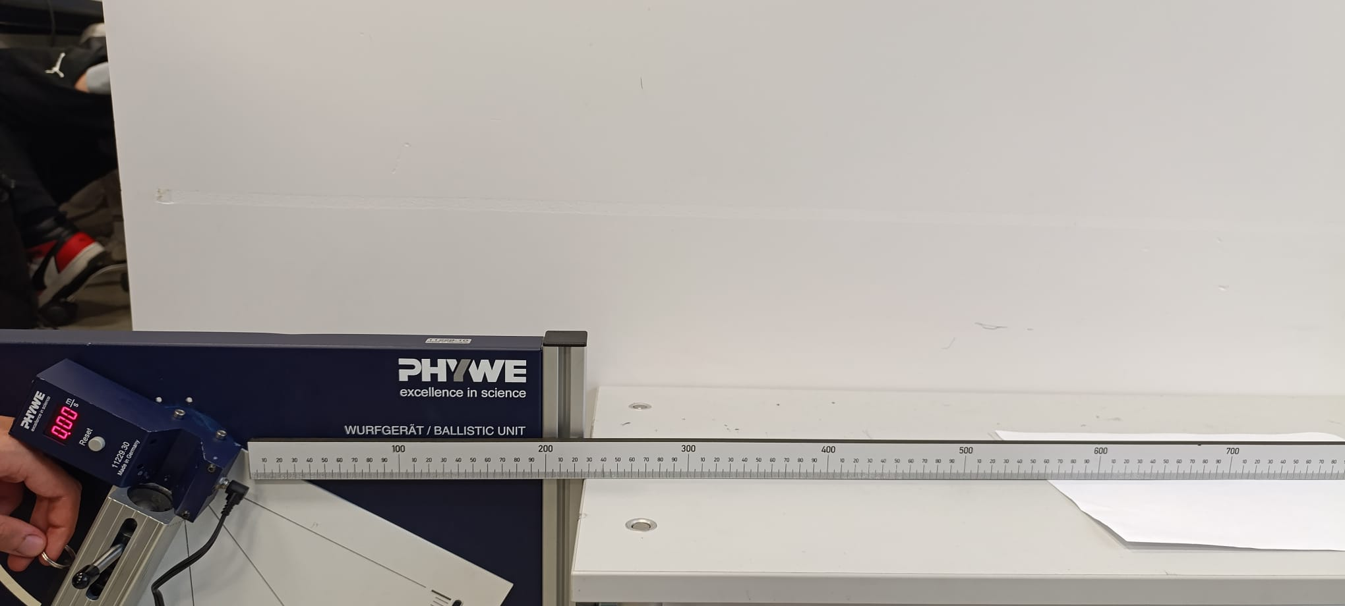
1. Figure 1: Projectile Launcher

Also, we use wood ball to analyze effects of mass on range and maximum height. We throw the wood ball at 30 degrees and first level of ballistic unit. Using spherical balls is essential because, in Tracker application we must determine the center of mass of balls and finding the center of mass of the spherical objects are the easiest ones.

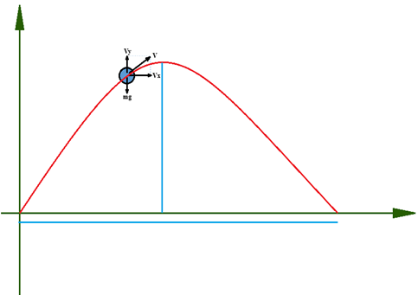
2. Figure 2: Projectile Launcher

After conducting our experiments, we made theoretical calculations and compare the theoretical and experimental results to observe the errors resulting from our experimental environment.

The horizontal vector of velocity is parallel to x-axis and the vertical vector of velocity is parallel to y-axis. The velocity vectors are:
V = V_{x} i^+ V_{y} j^
Equations for velocity:
V_{x}= V_{0x} + a_{x}t
V_{y}= V_{0y} + a_{y}t

If we assume that time is 0, then initial vertical velocity and initial horizontal velocity of the obejct are:
V_{x} = V_{0x} = V₀cosθ
V_{x} = V_{0x} = V₀cosθ

The force has effect on the ball is only gravity force “g” . Therefore, there is no force through x-axis and only force
a_{x =} 0
a_{y=} g
a = a_{x *} a_{y} => a = g.j^

We can calculate the range and h_{max} using the equations below:
Range = V_{x}t
h_{max} = (V₀)² * (sinθ)² / 2g
V_{y} = V_{0y} = V₀sinθ

